INSECT METAMORPHOSIS
Metamorphosis is one of the most widely used life-history strategies of animals. The dramatic differences between larval and adult forms allow the stages to exploit different habitats and food sources, and also allow the extreme adaptation of one stage for a particular role, such as dispersal. Insect metamorphosis may be defined as a series of changes through which an insect passes in its growth from the egg through the larva and the pupa to the adult. Metamorphosis is one of the most striking features of insect development as whenever the development at the insect embryo into adult takes place through a successive transitional marked change during the post embryonic development.
The process of development from the egg to the adult form involves different stages. The
immature stages are completely different in appearance and life style from the adult. The juvenile stage is called larva and that for the adult, imago. The stage between the larva and imago when differentiation or transformation is taking place but which is not active and does not feed is called the pupa. The whole process of development of the embryo into an adult involves casting of cuticle number of times. The process is called ecdysis. The interval between the ecdyses is called stadium and the form attained by an insect between two ecdyses is called instar. The egg hatches out into the first instar and at the end of this stadium it undergoes another ecdysis and assumes the second instar and so on. The last instar is the adult stage or imago. The number of instars to attain the adult stage in a particular species is fixed and it may vary in different species. When metamorphosis of an insect involves subsequent development of all the above mentioned stages then it is called complete metamorphosis. Thus an insect with complete metamorphosis has the egg stage, the larva stage, the pupa stage and the adult stage. However, all insects do not undergo the sequential transformation as found in complete metamorphosis. In some insects, there is no pupal stage and so alter the last moult the insect transforms itself to juvenile form. The juvenile form is not identical to the adult. Though the juvenile stages of crickets and cockroaches are small versions of the adult but the wings and external reproductive organs are not fully formed and gradually develop these structures as the insects proceeds from one instar to the next showing some degree of metamorphosis. This type of development is called as partial or incomplete metamorphosis. The development of the wings of insects differ greatly in the above two types of metamorphosis. In complete metamorphosis wings are never developed during the larval stage. Folded wings are developed internally within the pupa and so the adult emerges from the pupa with fully developed wings. But in incomplete metamorphosis wings are developed externally as small outgrowth in early instar stage which gradually increase in size after succeeding moults and finally wings are fully formed after the last moult. Some primitive insects (e.g. Springtails of the order Collembola) do not have the metamorphosis and they only increase in size from juvenile to adult. Moulting may occur in the adult stage in these insects.
TYPES OF METAMORPHOSIS
Different groups of insect show different types of metamorphosis. Complete metamorphosis and incomplete metamorphosis are two growth types of insect metamorphosis where the body form of insects changes during their lifecycle. Complete metamorphosis is the type of insect development that includes egg, larva, pupal, and adult stages, which differ greatly in morphology . The lifecycle of butterflies, ants, fleas, bees, beetles, moths, and wasps are examples of the complete metamorphosis. Incomplete metamorphosis refers to a type of insect development in which gradual changes occur in the insect during the development from the egg to the adult. The three stages of the incomplete metamorphosis are egg, nymph, and adult. On the basis of the type of metamorphosis, the insects are classified into different groups and these are as follows:
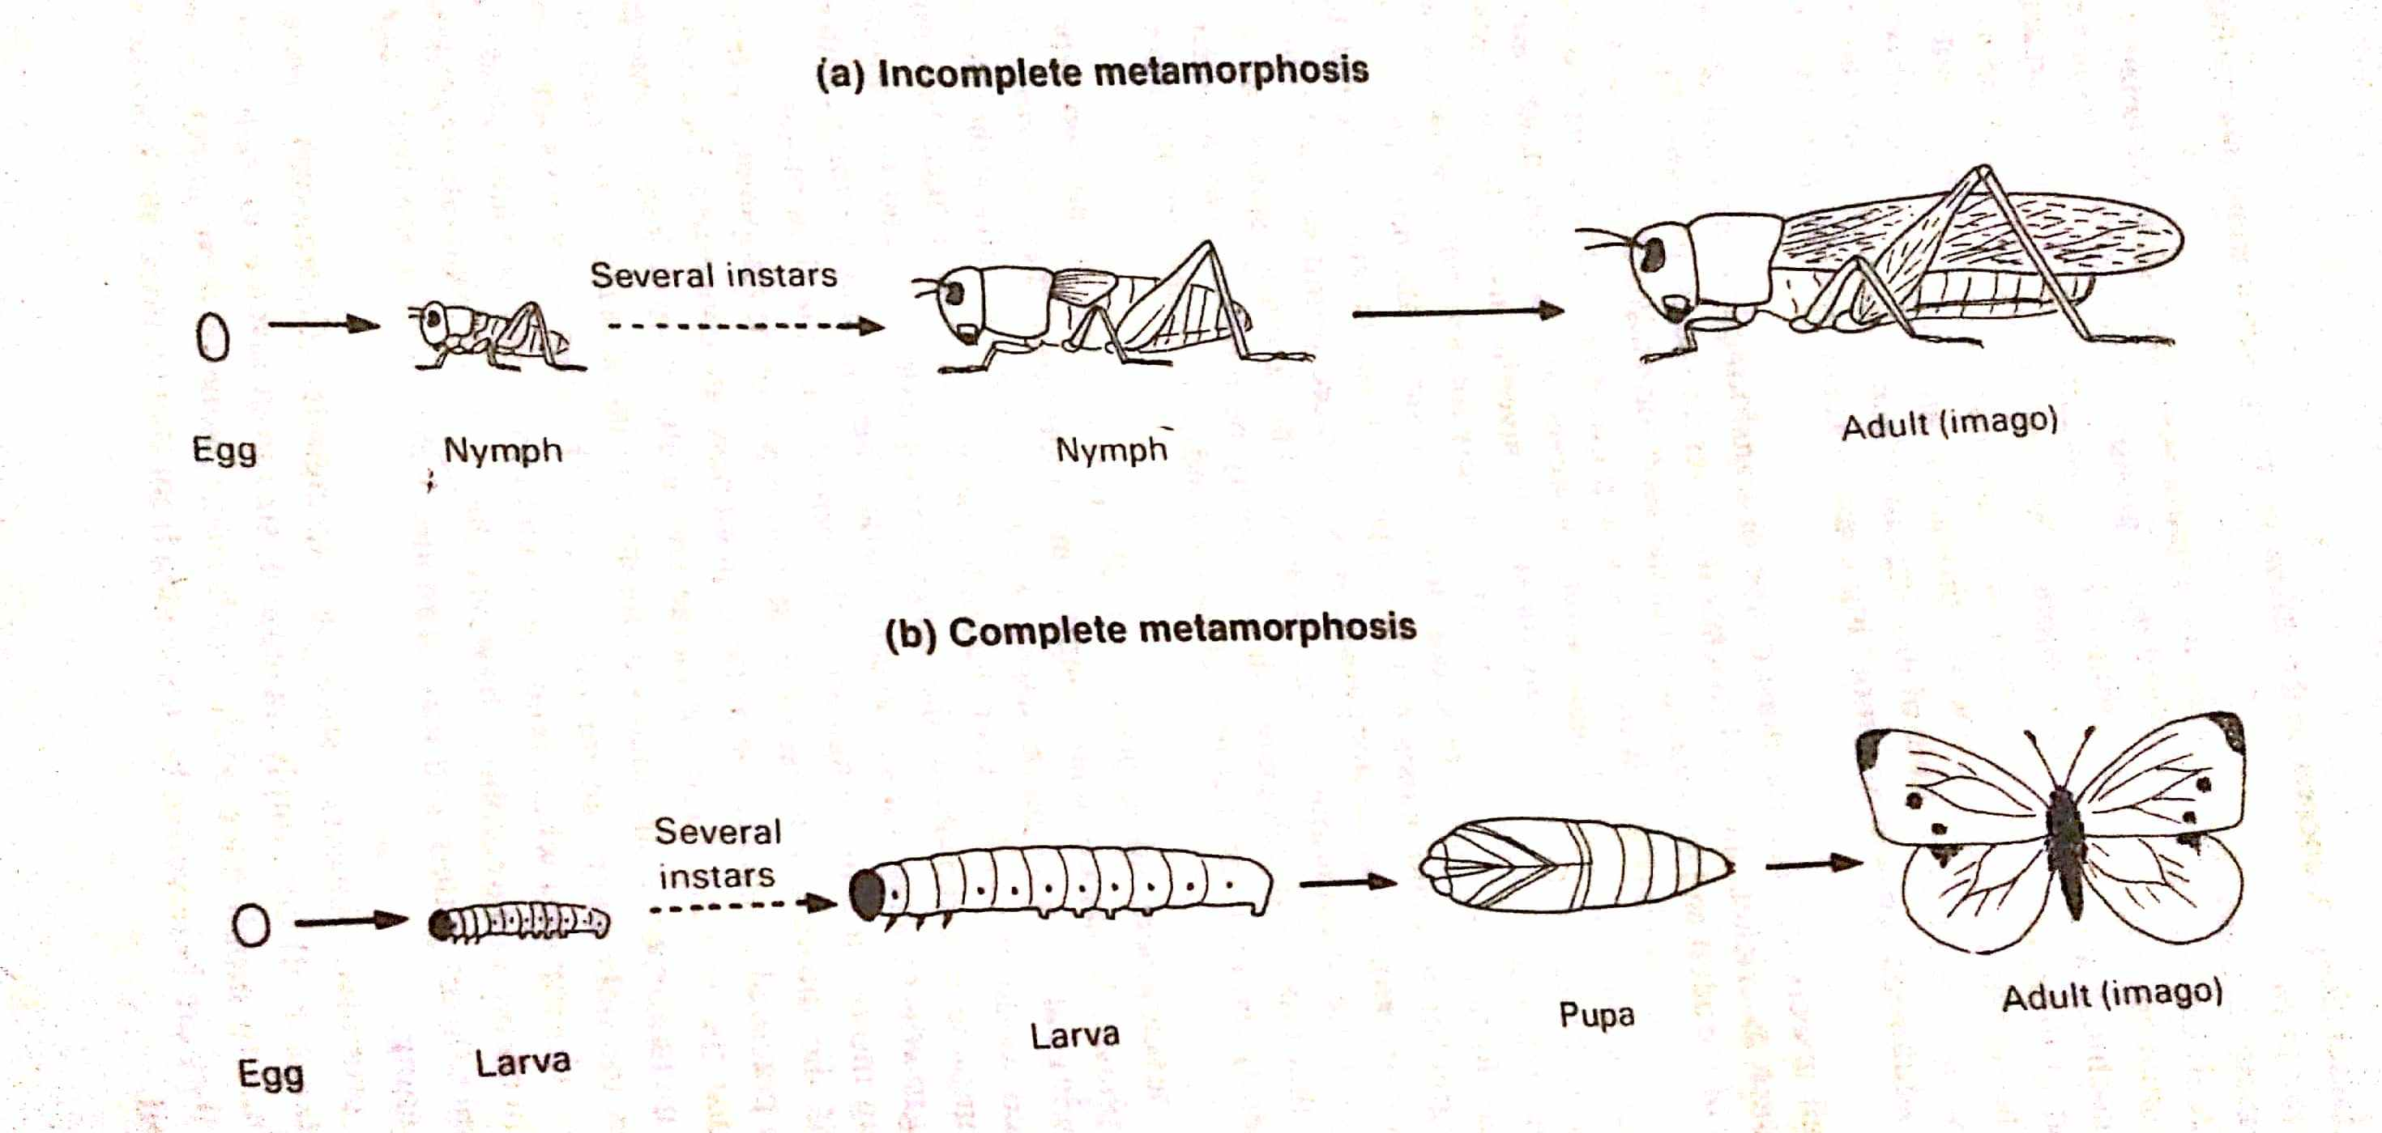

Fig: Types of Insect Metamorphosis

Ametabolic Metamorphosis:
In lower insects (Collembola, Thysanura) the young which hatches from an egg is a miniature of the adult and is called a nymph, it differs from the adult in having immature reproductive organs; by several moultings and growth it becomes an adult. These insects are primitively wingless, they are also called Apterygota, e.g., Lepisma, the change from young to adult is negligible, such insects are ametabolic because there is no metamorphosis.
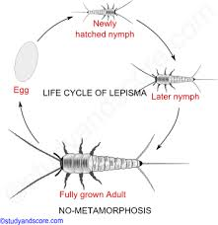
Fig: Ametabolic Metamorphosis in Lepisma

Hemimetabolic Metamorphosis
In winged insects the adult differs in several respects from the young, such insects are said to undergo metamorphosis in becoming adults. The nymph which hatches from the egg has a general resemblance to the adult in body form, type of mouth parts and possession of compound eyes, though these nymphs may have adaptations associated with their particular habits of being aquatic, swimming or burrowing. In these the change from nymphs to adults is a gradual process in which appendages, mouth parts, antennae and legs of the nymph grow directly into those of the adult. Wings develop gradually as external outgrowths of thorax and are visible externally in the nymphal instars, because of their external wing development they are also called exopterygota. The reproductive organs mature gradually. Insects showing this slight change from nymph to adult are known as heterometabolic (gradual), they include Dictyoptera, Orthoptera, Isoptera, Hemiptera and Anoplura.

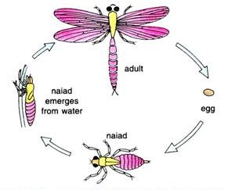

Fig: Hemimetabolic Metamorphosis in Dragonfly

Holometabolic Metamorphosis:
In Lepidoptera, Coleoptera, Hymenoptera, Diptera, Siphonoptea, etc., the young which hatches from the egg is called a larva, the larva is very different from the adult in structure, body form, mouth parts, legs and in its mode of life, the larva has lateral ocelli in place of compound eyes, it feeds voraciously, grows, moves about and undergoes ecdyses. The larva is so different from the adult that it first changes into a resting, quiscent instar called a pupa which is often enclosed in a cocoon secreted by the labial glands of the larva. Great transformation occurs in this instar, wings develop internally from pockets of the hypodermis, and they are not visible from outside. Because wings develop from internal imaginal discs these insects are also called endopterygota. Appendages are formed, muscles, tracheae and parts of the alimentary canal are replaced by corresponding organs of the imago. Such vast changes are called holometabolic metamorphosis.
In holometabolic insects there is an internal reconstruction during late larval and pupal instars. Larval organs, with the exception of central nervous system and developing reproductive organs, are disrupted, their breaking down is called histolysis, this is brought about by phagocytes which feed on the organs, and products of their digestion are then used for building new structures. The building of new structures is brought about by growth centres called imaginal buds or discs. Imaginal discs are groups of formative cells which are set aside in the larva, they are the rudiments of future organs of the imago, they form legs, mouth parts, internal organs and wings. This process of formation of organs of an imago from imaginal discs inside the pupa is known as histogenesis and it results in the formation of the imago. Thus, two postembryonic processes occur in all insects, the first is growth in the young and the second is metamorphosis, in both of which moulting takes place; both processes are controlled by hormones of endocrine glands.

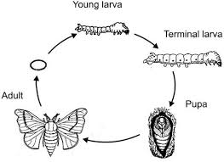
Fig: Holometabolic Metamorphosis in Butterfly

ROLE OF HORMONES IN INSECT METAMORPHOSIS
.
The role of hormones in the physiology of molting was first described by V. B. Wigglesworth in the 1930's. When an immature insect has grown sufficiently to require a larger exoskeleton, sensory input from the body activates certain neurosecretory cells in the brain. These neurons respond by secreting brain hormone which triggers the corpora cardiaca to release their store of prothoracicotropic hormone (PTTH) into the circulatory system. This sudden "pulse" of PTTH stimulates the prothoracic glands to secrete molting hormone (ecdysteroids).
Molting hormone affects many cells throughout the body, but its principle function is to stimulate a series of physiological events (collectively known as apolysis) that lead to synthesis of a new exoskeleton. During this process, the new exoskeleton forms as a soft, wrinkled layer underneath the hard parts (exocuticle plus epicuticle) of the old exoskeleton. The duration of apolysis ranges from days to weeks, depending on the species and its characteristic growth rate. Once new exoskeleton has formed, the insect is ready to shed what's left of its old exoskeleton. At this stage, the insect is said to be pharate, meaning that the body is covered by two layers of exoskeleton.
As long as ecdysteroid levels remain above a critical threshold in the hemolymph, other endocrine structures remain inactive (inhibited). But toward the end of apolysis, ecdysteroid concentration falls, and neurosecretory cells in the ventral ganglia begin secreting eclosin hormone. This hormone triggers ecdysis, the physical process of shedding the old exoskeleton. In addition, a rising concentration of eclosion hormone stimulates other neurosecretory cells in the ventral ganglia to secrete bursicon, a hormone that causes hardening and darkening of the integument (tanning) due to the formation of quinone cross-linkages in the exocuticle (sclerotization).
In immature insects, juvenile hormone is secreted by the corpora allata prior to each molt. This hormone inhibits the genes that promote development of adult characteristics (e.g. wings, reproductive organs, and external genitalia), causing the insect to remain "immature" (nymph or larva). The corpora allata become atrophied (shrink) during the last larval or nymphal instar and stop producing juvenile hormone. This releases inhibition on development of adult structures and causes the insect to molt into an adult (hemimetabolous) or a pupa (holometabolous).
At the approach of sexual maturity in the adult stage, brain neurosecretory cells release a brain hormone that "reactivates" the corpora allata, stimulating renewed production of juvenile hormone. In adult females, juvenile hormone stimulates production of yolk for the eggs. In adult males, it stimulates the accessory glands to produce proteins needed for seminal fluid and the case of the spermatophore. In the absence of normal juvenile hormone production, the adult remains sexually sterile.

